Capstone Project Two

Topic modeling for news articles

**Final Report**

by Yiding Weng

June 05, 2019

# **Problem**

With the rapid growth of internet and online information services, printing medias, more and more information is available and accessible. Explosion of information has caused a well recognized information overload problem. There is no time to read everything and yet we have to make critical decisions based on whatever information is available. Without absorbing the text information line by line, how to know what is the significant writing worth paying attention? What is the central theme?

One of the primary applications of natural language processing is to automatically extract what topics people are discussing from large volumes of text. Knowing what people are talking about and understanding their problems and opinions is highly valuable to businesses, administrators, political campaigns. It will be very helpful to have an automated algorithm that can read through the text documents and automatically output the topics discussed.

I will use news articles as the source of information, and extract the naturally discussed topics.

**Data**

**Proposed Data Collection:**

All the news: 143,000 articles from 15 American publications

Data Location: <https://www.kaggle.com/snapcrack/all-the-news>

# **Approach**

I will be using the Latent Dirichlet Allocation (LDA) from Gensim package along with the Mallet’s implementation (via Gensim). Mallet has an efficient implementation of the LDA. It is known to run faster and gives better topics segregation.

We will also extract the volume and percentage contribution of each topic to get an idea of how important a topic is.

# **Data wrangling**

**Download nltk stop words and spacy model**

We will need the stopwords from NLTK and spacy’s en model for text pre-processing. Then we will be using the spacy model for lemmatization. Lemmatization is converting a word to its root word.

For example: the lemma of the word ‘machines’ is ‘machine’. Likewise, ‘walking’ –> ‘walk’, ‘mice’ –> ‘mouse’ and so on.

**Data sampling**

This version of the dataset contains about 142k news articles from 15 different medias. This is available as <https://www.kaggle.com/jannesklaas/analyzing-the-news/data>. Due to the limited computing power, I will take a sample of 30% of the total data for our study in this project.

**Data cleaning**

'title' and 'content' are the important features that have the text information we are interested to study. Since this title dataset does not have empty fields in 'title' or 'content' information, we will not remove any rows of data.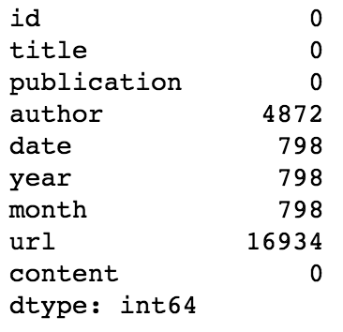

**Remove emails and newline characters**

There are many emails sign (@), newline and extra spaces that is quite distracting. So get rid of them using regular expressions. After removing the emails and extra spaces, we need to break down each sentence into a list of words through tokenization, while clearing up all the messy text in the process.

**Creating Bigram and Trigram Models**

Bigrams are two words frequently occurring together in the document. Trigrams are 3 words frequently occurring. Gensim’s Phrases model can build and implement the bigrams, trigrams, quadgrams and more. The two important arguments to Phrases are min_count and threshold. The higher the values of these param, the harder it is for words to be combined to bigrams.

Some examples in our example are: ‘health_insurance’, ‘health_care’, ‘white_house’ etc.

# **Exploratory analysis**

As of v2.0, spaCy supports models trained on more than one language, in this case is English. This is especially useful for named entity recognition.

To list a few examples: ( [Annotation Specifications](https://spacy.io/api/annotation#_title) <https://spacy.io/api/annotation#named-entities>)

I first looked at the distribution of the number of the articles from different publications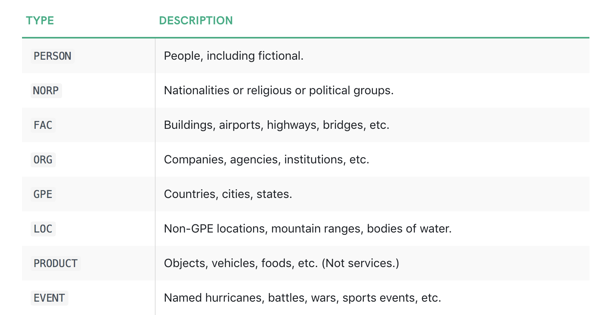

And found out Breitbart, New York Post and NPR has the most number of news articles, so I use them for the target of comparison.

After that I observed the distribution of types of predefined words by spaCy,

Which is listed below: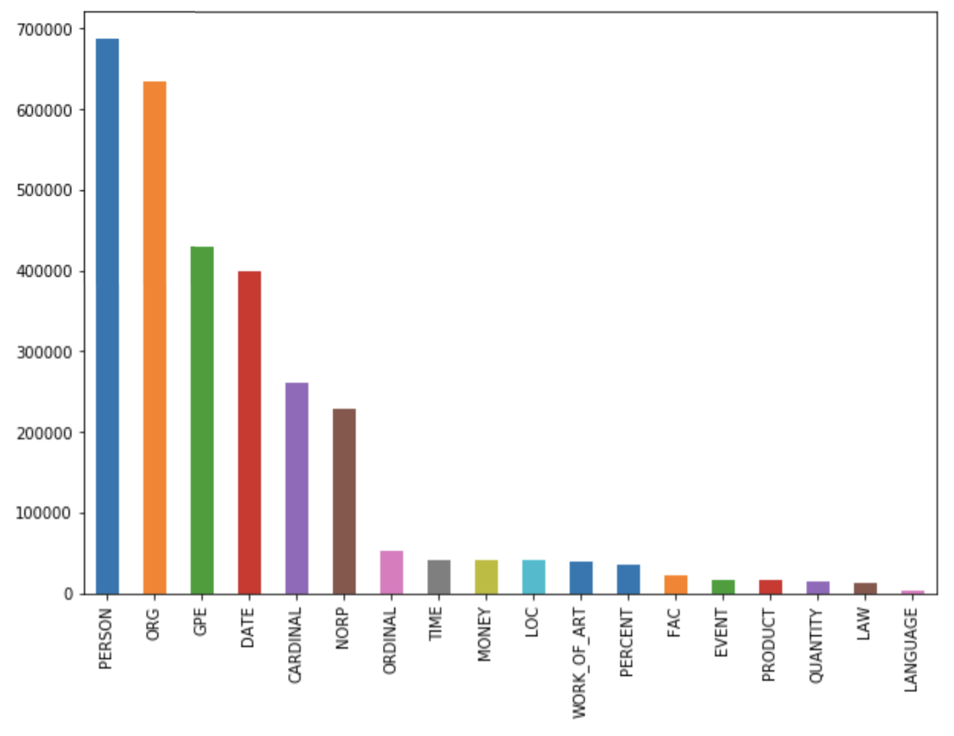

And I decided to look at some most occurring words in each media source.

From Breitbart: trump, state, people, president, news

From New York Post: year, time, people, day, trump

From NPR: people, year, trump, time, state

Since ‘Trump’ in all three medias, but the frequencies of occurrence are different, I want to observe if such difference are statistically significant to notice such fact.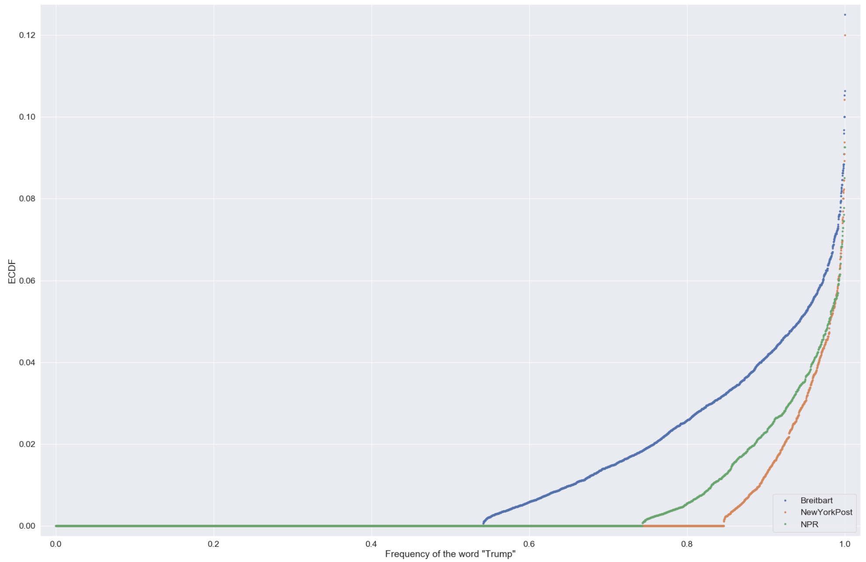

**Statistical analysis**

We can see that the differences of the occurring frequency of the word 'trump' from three different publications are much clearer in the ECDF. Breitbart has almost half of the articles contains the word 'trump'.

New York Post and NPR has more similar frequency for the word 'trump', if we can conclude that the frequency difference between them are statistically significant, then we can also conclude the difference between these two(New York Post, NPR) and Breitbart are much more statistically significant given its wider margin.

**Preform hypothesis test**

H0: p = 0 H1: p ≠ 0

Null hypothesis:

There is no difference between the occurring frequency of the word 'trump' between New York Post and NPR (frequency difference is 0, p = 0)

Alternate hypothesis:

There is difference between the occurring frequency of the word 'trump' between New York Post and NPR (frequency difference is not 0, p ≠ 0)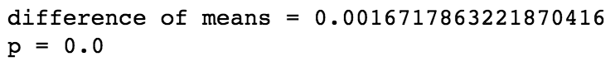

We get a p-value of 0.0, which suggests that there is a statistically significant difference. We got a difference of 0.00167 between the means. You should combine this with the statistical significance, which means the difference between the frequency of the word ‘Trump’ from New York Post and from NPR is substantial.

**Cluster modeling  
Create the Dictionary and Corpus needed for Topic Modeling**

The two main inputs to the LDA topic model are the dictionary(id2word) and the corpus.

To list, to show a part of the corpus:

[[(0, 1), (1, 1), (2, 1), (3, 1), (4, 1), (5, 1), (6, 1), (7, 1), (8, 1), (9, 1), (10, 1), (11, 1), (12, 1), (13, 1), (14, 3), (15, 1), (16, 1), (17, 1), (18, 1), (19, 2), (20, 3), (21, 1), (22, 2), (23, 1), (24, 1), (25, 1), (26, 1), (27, 1), (28, 1), (29, 1), (30, 1), (31, 1), (32, 1), (33, 1), (34, 1), (35, 1), (36, 1), (37, 1), (38, 1), (39, 2), (40, 1), (41, 1), (42, 1), (43, 1), (44, 1), (45, 1), (46, 2), (47, 1), (48, 1), (49, 1), (50, 1), (51, 1), (52, 1), (53, 1), (54, 2), (55, 1), (56, 2), (57, 7), (58, 1), (59, 1), (60, 1), …

Gensim creates a unique id for each word in the document. The produced corpus shown above is a mapping of (word_id, word_frequency). For example, (0, 1) above implies, word id 0 occurs once in the first document. Likewise, word id 14 occurs three times and so on. This is used as the input by the LDA model. To see what word a given id corresponds to, pass the id as a key to the dictionary.

You can see a human-readable form of the corpus itself.

[[('ability', 1),

('accomplished', 1),

('acknowledge', 1),

('address', 1),

('adviser', 1),

('advocacy', 1),

('aim', 1), … ]…[…]]

**How to find the optimal number of topics for LDA**

My approach to finding the optimal number of topics is to build many LDA models with different values of number of topics (k) and pick the one that gives the highest coherence value. Topic coherence value signifies the quality defined by % of conformance as per some predefined standards. Choosing a ‘k’ that marks the end of a rapid growth of topic coherence usually offers meaningful and interpretable topics. Picking an even higher value can sometimes provide more granular sub-topics. If you see the same keywords being repeated in multiple topics, it’s probably a sign that the ‘k’ is too large.

The compute_coherence_values() trains multiple LDA models and provides the models and their corresponding coherence scores.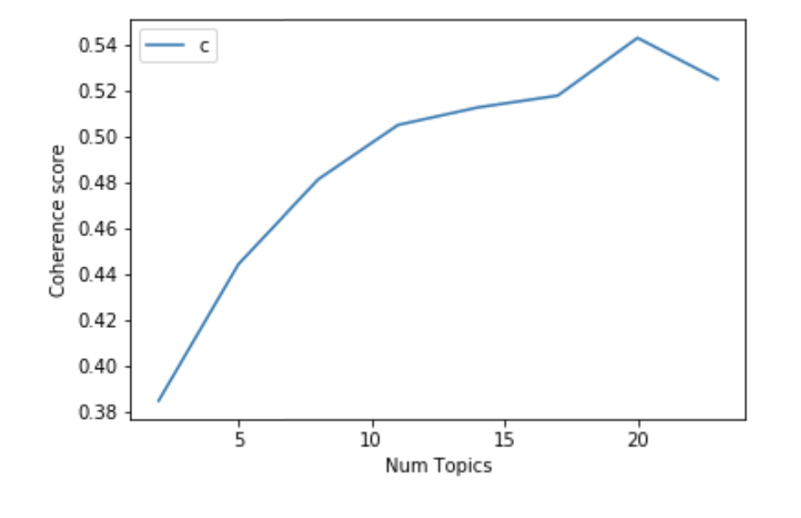

If the coherence score seems to keep increasing, it may make better sense to pick the model that gave the highest CV before flattening out. This is exactly the case here.

So for further steps I will choose the model with 10 topics itself, topic number going well above 10 have good coherence scores but may have repeated keywords in the topic.

**Visualize the topics-keywords**

Now that the LDA model is built, the next step is to examine the produced topics and the associated keywords. There is no better tool than pyLDAvis package’s interactive chart and is designed to work well with jupyter notebooks.

Now we can see the data has been divided into 10 groups, and as we go through each of the circle which represent different topics, from its own list of keywords we are able to estimate the theme of each topic.

Topic 0 (circle 7): Crime

Topic 1 (circle 9): Foreign affairs

Topic 2 (circle 1): Ge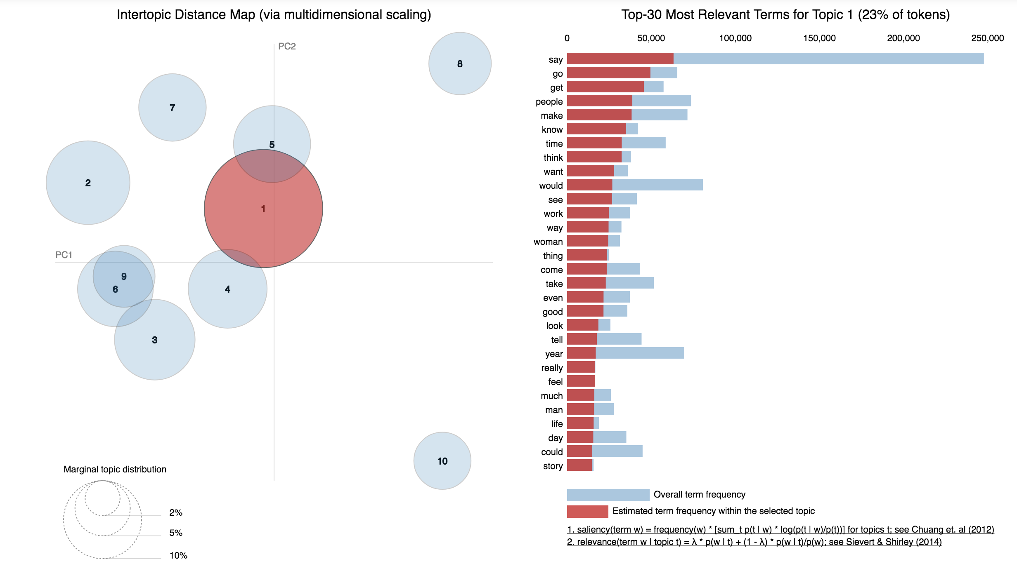neral News

Topic 3 (circle 5): Legal issues

Topic 4 (circle 3): Sports

Topic 5 (circle 10): Fashion & Entertainment

Topic 6 (circle 2): Election

Topic 7 (circle 8): Health & Environment

Topic 8 (circle 4): Education & Social work

Topic 9 (circle 6): Finance & Economy

**Model result analysis**

As the model has already put each each of the news documents into a category group, we can access the performance of this model by reading the content of the news and judging if the attributed topic is appropriate from human perspective.

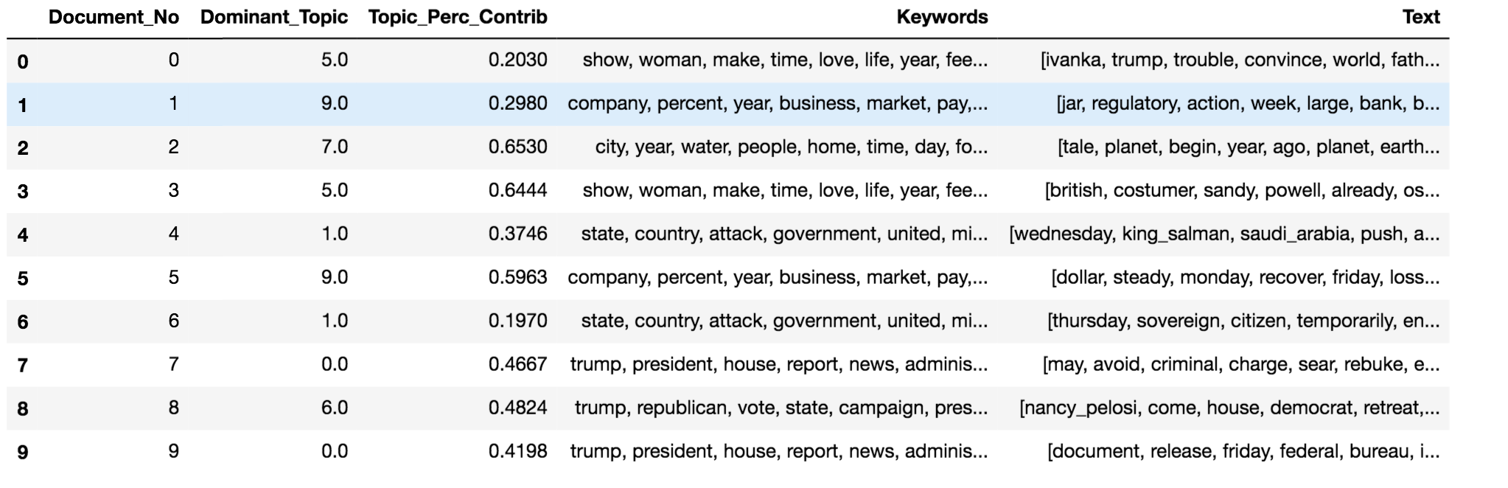

From the top of the data frame of the notebook, we can choose the first five articles as a sample:

0. Ivanka Trump just got booed in Germany for calling her father a champion of women

1. At Debate, Hillary Clinton Leaves Questions About Approach to Banks - The New York Times

2. Why Mars Is the Best Planet

3. Sketch To Impress: How An Oscar-Winning Designer Costumes The Stars

4. What to Make of the Saudi Shake-up

Though my reading, I extract the following keywords and give the topic to these articles

0. Keywords: Ivanka Trump, women, presidency, equality, entrepreneurship

topic: general news, election

1. Keywords: Hillary Clinton, Wall Street, banks, federal regulator, congress, economy, financial

topic: Finance, economy

2. Keywords: Mars, water, Earth, life, planet, science, NASA,

topic: Science, Environment

3. Keywords: Oscar, costume design, Cate Blanchett, dress,

topic: Fashion, Entertainment

4. Keywords: Saudi Arabia, Salman, successor, ruler, monarchy, ambassador

topic: Foreign news

Then we can compare my defined topics with the ones defined by the model

0. my topic: general news, election

model topic: Fashion & Entertainment

1. my topic: Finance, economy

model topic: Finance & Economy

2. my topic: Science, Environment

model topic: Health & Environment

3. my topic: Fashion, Entertainment

model topic: Fashion & Entertainment

4. my topic: Foreign news

model topic: Foreign affair

Beside the first one, my conclusion is a bit different from the model conclusion, since the article itself span across multiple areas. But other than that the results are pretty much the same.

**Conclusion**

At the beginning stage of the project, we extract the words that can mostly represent the content and we were able to tell there are different emphasis within the news content from different media source by identifying the high frequency words, even if some of the words came out as frequent words in multiple sources, the significant difference in their frequencies signifies the differences in weights.

Throughout the modeling experience, we transformed the dataset into dictionary and corpus to feed into the LDA model, and by comparing coherence score and the number of classifying groups, we decided to divide the news documents into ten groups given its corresponding optimal coherence score, and gave each group a central topic based on its keywords. Finally by comparing the modeling result with human interpretation of the article and judgment about the theme topic, I can conclude the model is reliable to divide news articles into 10 distinct groups.

**Future work**

In the process of analyzing the modeling result. I used my own reading and interpretation of five news articles as an rough assessment to measure the performance of the model. This approach can be improved in reducing bias by involving more people and reading larger amount of the articles sampled from different source of news media. More than that. When each reader is extracting keywords from the documents they are reading, a metric can be utilized to quantitively record the proportion of keywords identified by both human users and the model, which will be effectively in improving the model performance.

**Recommendation for clients**

In this project the LDA topic identifying model can identify main topics of large amount of news articles that’s too much for human to process. Since the modeling paradigm is only based on the word frequency, which means this model can be also used to identify topics and central information in other text sources such as legal, historical or financial documents, and even documents of other languages. So that more time can be saved from using man power to obtain the same amount of the information.